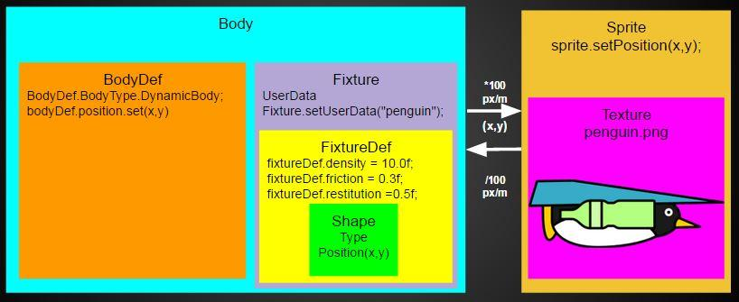

Box2D is a physics plugin in libgdx. It simulates real physics in the world class, which contain the body classes. You define and update the world based on the parameters given. You can make any kind of shape around the body.

world = new World(new Vector2(0f, -9.8f), true);//9.8m/s2 down

world.step(1 / 60f, 6, 2);//Step the simulation of the box2d world to 60fps

When the world updates Box2d calculates everything in the background using Newtons, Metres and Kilograms for the units. This means we have to create a pixel to meter conversion for the sprite.

First you make a BodyDef ,set the type of body and set the position to the libgdx sprite

bodyDef = new BodyDef();

bodyDef.type = BodyDef.BodyType.DynamicBody;

bodyDef.position.set(0,

(Gdx.graphics.getHeight() / 7 / 3 + sprite.getHeight() / 2) / 100f);//100 pixels per metre

Then you create a shape to add to the FixtureDef which makes the Fixture Body

shape = new PolygonShape();

shape.setAsBox(sprite.getWidth() / 2 / 100f, sprite.getHeight()

/ 2 / 100f);//Set the body's shape to a box

FixtureDef fixtureDef = new FixtureDef();//Fixture def defines how the body acts on other box2d bodies

Then you add everything to the Body and create it inside the world, and set userdata if you want

body = world.createBody(bodyDef);

body.createFixture(fixtureDef).setUserData("penguin");//Pass the fixturedef to the body

To move your Bodies around

body.setLinearVelocity(velocity x,velocity y);//m/s

body.applyForceToCenter(force x, force y, true);//Newtons

body.setAngularVelocity(velocity v);

body.setTransform(position x,position y,angle a)